UBD FPT Innovation Lab

Game Design Document

TOWERING JUMP

Group Members

NUR AFIFAH ILYANA BINTI ILHAM

NURBAZILAH BINTI HAJI METUSSIN

RAHIMAH BINTI ABD AZIZ

MUHAMMAD HAFIY BIN HASSAN

MOHAMMAD OMAR BIN HAJI IBRAHIM

Artist: Hafiy, Omar, Afifah

Designer: Rahimah, Hafiy, Afifah

Programmer: Omar, Bazilah, Rahimah, Hafiy, Afifah

Animator: Bazilah, Rahimah, Hafiy

Producer: Omar

Introduction

A platformer game using the Unity game engine, where the player jumps up a very tall tower. There the player will encounter many obstacles along the way.

The game will be a vertical oriented android game. It will be both 2d and 3d platformer game. The characters and background will all be 2d and everything else (tower and platform) is 3d. The main character will jump to one platform to another, all surrounded around a very tall tower. There will be enemies; the players have a choice to avoid them or defeat them to gain extra score points. Rather than just one side of the tower, the player can rotate the building with by using an in-game button.

The objective is to defeat as many enemies as you can, collect as much coins as you can, and climb the tower as high as you can; that will determine the player’s end score.

Game Description

Genres: Action, adventure

Game Element: Jumping, collecting, chasing, combat, shooting

Game Content: Fast Paced, action

Style: Cartoon

Game Sequence: No Ending

Player Immersion: Tactical

Game Technical: 2D for Characters, 3D for environment

Replay: Respawns at beginning

Game Technical

The game will have a mix of both 2D and 3D assets. It is a 3D platform game; the ground, tower, and pick up items for example are all 3D models where else the characters (player and enemies) are 2D.

The proportion will be vertical. For the view, the camera will follow the Player as it climbs up the tower, however if the player falls, the camera will not follow. If the Player went beyond the camera’s field of view, the game will trigger the Game Over scene. The Player can also interact with an in-game button which will cause the tower to rotate. To achieve this effect, the player will rotate simultaneously with the camera, creating a different perspective.

Platform: Android, iOS

Language: C#

Device: Mobile

Game Atmosphere

A challenging but fun and cartoonish graphics with cheerful background music.

Game Play

Opening the Game Application

* The game will show a short splash screen of the game title or the group name (or logo). After that will be the Main Menu scene which consists of three buttons; Start Game, Change Character (of the Player), and Game Options.

Game Options

* Enable or disable the background music,
* Enable or disable the sound effect (eg shooting audio, jump audio)
* Information about the game (version and hints)

Game Levels

* There will be 7 environmental changes throughout the gameplay; cave, ocean, ground, forest, snowy mountain, sky city, and lastly space. If the player reaches the Space environment, then it will indefinitely be only space throughout.

Player’s Control

* There will be two buttons at the bottom right of the screen; jumping and shooting.
* At the bottom left of the screen will be one joystick; to control the player’s movement. The player can only move horizontally (along the x axis) and jump vertically (along the y axis). The Player can not move forward and backward (z axis)

Player’s Properties

* Health; by the start of the game, the player will have 3 hearts. The player can lose hearts if the Player came in contact with the enemies or the obstacles.
* Weapons; different playable characters will have their own specific weapon. These weapons cannot be changed in the middle of game play.

Winning

* Since the game have no ending, there will be no Win condition. The objective of the game is to score as high as the player can. The highest score will be recorded.

Losing

* Health reaches zero
* Character falls down; beyond the camera’s field of view

Number of playable characters

* Three; cat, dog, monkey. Each have their own weapon, advantages and weaknesses.
* The cat will have higher Attack points but less on Defense; sub machine gun
* The dog will have higher Defense points but less on Attack; shotgun
* The monkey will be noticeably faster but less on defense; long sword

Number of enemies

* 14 in total from all environments
* Cave (3); Bat, snake, spider
* Ocean (3); Piranha, shark, fishman
* Ground (3); Ghost, vampire, skeleton
* Forest (1); Boar
* Snowy Mountain (1); Alien version 1
* Sky City (1); Vultures
* Space (2); Alien version 2, alien version 2 (slightly bigger and scary)
* The enemies can appear in different environment occasionally but these are the main ones.

Number of Obstacles

* Since the player will jump up the tower, there will also be obstacles falling down from above. Total obstacles; 5
* Cave (1); boulder
* Ocean (1); Poisonous bubble
* Ground and Sky city (1); toxic gas
* Snowy Mountain (1); snow ball
* Space (1); meteor

Time of Game Play

* Unlimited

Player Rewards (Power-ups and Pick-ups)

* POTION; a power-up that makes the player invincible for 5 seconds. Enemies and obstacles will not have any effect on the player. If they come in contact, the enemies will automatically be defeated and the obstacle will break.
* Normal and Special Diamonds; increases score
* Drumstick Meat; heals player. Adding one Heart to Health

Scoring System

* Increases as the player moves up the tower
* Increases when the player collects Diamond; Normal diamond will add 10 points to the score, and Special Diamonds will add 30 points
* Increase if the player defeats an enemy or break the obstacles. One enemy or obstacle will add 50 points

Device Compatibility

* Minimum API Level; Android 4.1 ‘Jelly Bean’ (API Level 16)
* API Compatibility Level; .NET 2.0 Subset

Game Architecture

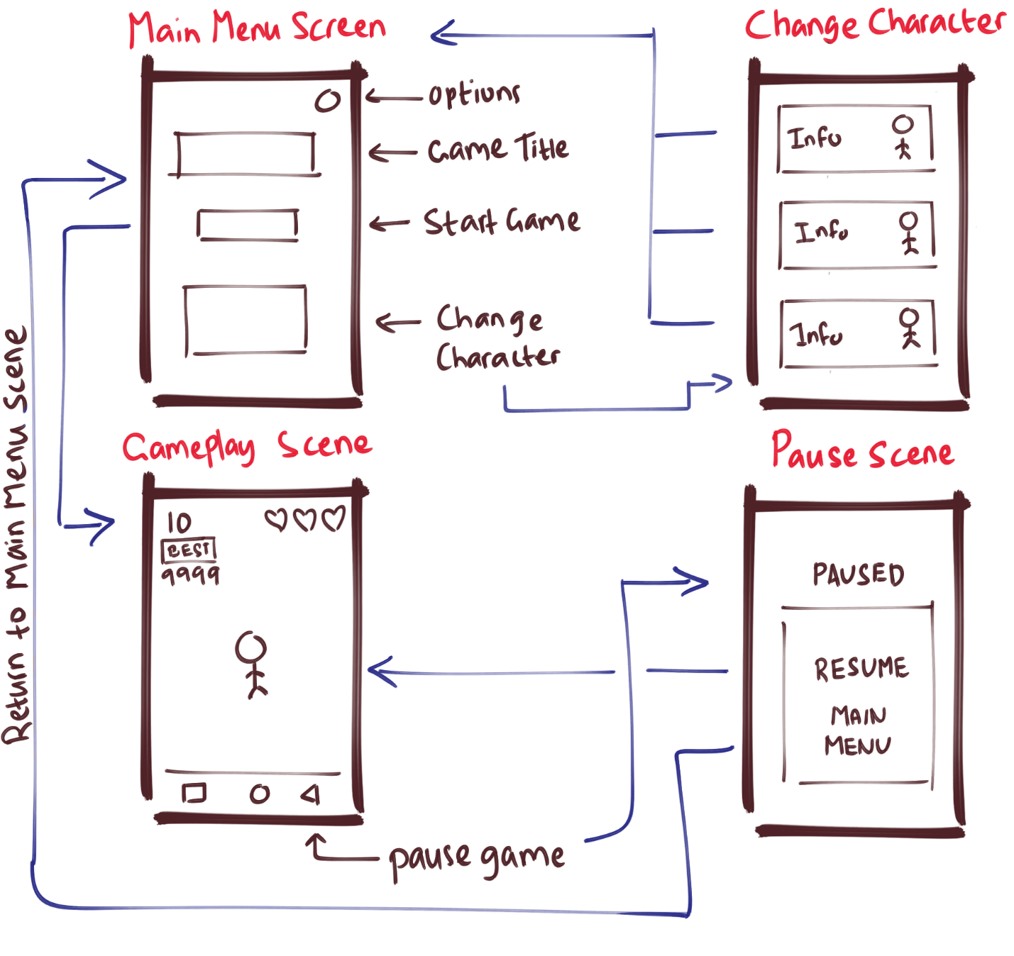

The Blue Arrow represents a change in scene when a button is clicked.

Overall there will be 2 Scenes (Main Menu and Gameplay Scene)

The change character scene is under main menu and the pause scene is under the game play scene.

The game will start at the Main Menu. There it will have 3 interactable buttons (options, start game, change character)

The change character panel will show the playable character’s information (stats and type of weapon)

Concept Art

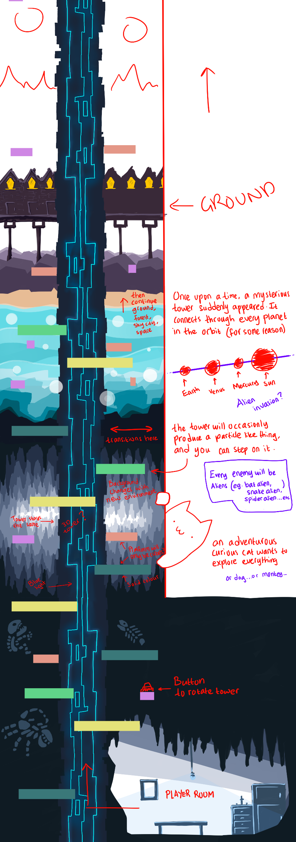

As shown from the image above, the player will initially start in the player’s room. Then the player must move to the left and start climbing up the tower by jumping off the many platforms surrounding the tower at the middle.